Exercise 1: After doing well in your ﬁnance classes, you landed a job at the IMF. Your salary is $100,000, and your contract is for 5 years. Your salary will stay the same during the 5 years and, since you are at the IMF, you are not subject to taxes. If you do well (which we assume will happen with certainty), you will get a permanent contract. Under this contract, your salary will grow at the rate of 3% per year, until retirement. Retirement will occur in 30 years after your contract becomes permanent.
For simplicity, assume that your salary is paid at the end of each year. In other words,
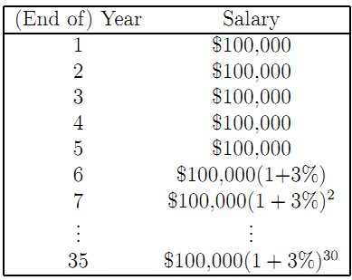
We assume that the interest rate is 4% (and will stay at 4% forever).
(a) What is the value of your human capital? That is, what is the PV (as of today) of all your future earnings?
(b) Assume that you spend 70% of your salary, and deposit the remainder in a savings account, which pays the rate 4%. How much money will you have in the savings account just after you received your ﬁfth salary (end of year 5)? (You deposit only 30% of that salary in the savings account.)

Exercise 2, Retirement planning: Mr. Jones is contemplating retirement. He is 55 and his net worth now is $2 million. He hopes that after retirement he can maintain a lifestyle that costs him $100,000 per year in today’s dollars (i.e., real dollars, inﬂation adjusted).
If he retires, he will invest all his net worth in government bonds that yield a safe annual return of 5%. Inﬂation is expected to be 2% per year. Ignore taxes.
(a) Is Mr. Jones rich enough to retire today if he lives until (i) 80 (ii) 100 (iii) 115?
(b) Mr. Jones thinks he will live until about 100. What advice will you give him about retiring?

